Existing Model Analysis and Current Limitations
The following analysis and limitations are made for the old model from Ryan Engels.

Analysis of the Existing Model
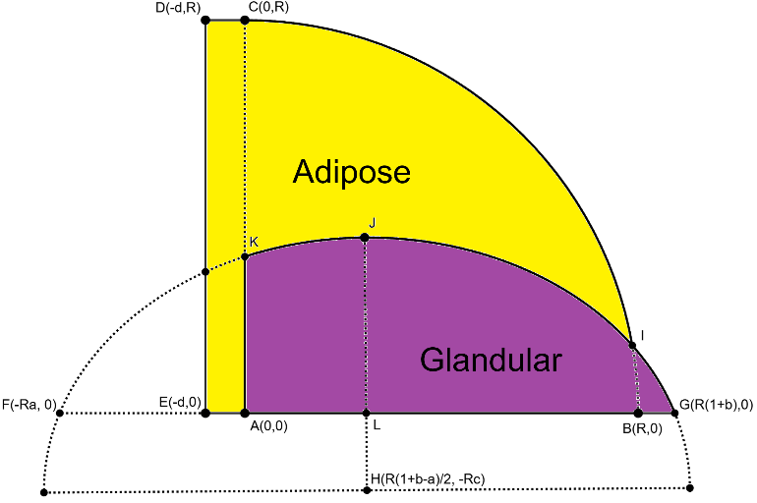
The existing finite element breast model, developed in previous work, is based on an axisymmetric geometry generated by revolving a two-dimensional cross-sectional profile into a three-dimensional structure. This approach provides a computationally efficient and numerically stable representation of the breast, making it suitable for controlled baseline simulations. However, the resulting geometry remains highly idealized, as it assumes rotational symmetry and does not explicitly represent anatomical asymmetry, local surface irregularities, or inter-subject variability. Furthermore, the internal organization of glandular tissue is simplified and does not fully reflect the complex spatial heterogeneity observed in real breast anatomy.
The model geometry is discretized using tetrahedral finite elements generated through a GMSH-based meshing workflow. Quadratic tetrahedral elements are used to improve accuracy during large nonlinear deformations characteristic of soft tissue biomechanics. As in many FEM breast models, the mesh design represents a compromise between numerical accuracy and computational efficiency. Coarse meshes reduce simulation time but may underestimate local deformation gradients and stress concentrations, whereas finer meshes improve biomechanical realism at the cost of increased computation time and potential convergence issues. In large deformation simulations, mesh quality remains particularly important, as poorly shaped or inverted elements can lead to numerical instability.
Material behaviour is described using a hyperelastic Mooney–Rivlin constitutive formulation:
W = C1(Ī1 − 3) + C2(Ī2 − 3)
where C1 and C2 are material coefficients and Ī1 and Ī2 represent the deviatoric strain invariants. This formulation is widely used in soft tissue biomechanics because it captures nonlinear large-deformation behaviour while remaining computationally efficient.
The heterogeneous model distinguishes between adipose and glandular tissue regions with different material properties. Adipose tissue is assigned a density of approximately 911 kg/m³, with Mooney–Rivlin parameters C1 = 109 Pa and C2 = 106 Pa. Glandular tissue is modeled with a density of approximately 1041 kg/m³, and parameters C1 = 230 Pa and C2 = 195 Pa. These values are based on ranges reported in literature for breast tissue biomechanics and were adjusted where necessary to maintain numerical stability during simulation. The relative stiffness hierarchy between adipose and glandular tissue is consistent with experimental observations reported in previous studies.
Heterogeneity is currently implemented using discrete tissue regions and scaling of material properties. Although this represents a substantial improvement over fully homogeneous models, the spatial distribution of tissue remains simplified and does not yet reproduce the complex glandular organization found in anatomical breast structures.
The simulation workflow in FEBio consists of two sequential stages. First, a static gravity-settling phase is performed to establish an equilibrium configuration under gravitational loading. Subsequently, a dynamic excitation phase is applied using a prescribed parabolic motion profile to simulate breast movement. Simulation outputs include nodal displacement fields, stress distributions, and relative volume changes, which are exported in VTK format for post-processing and visualization in Python.
Overall, the introduction of heterogeneous tissue properties significantly improved the biomechanical realism of the model compared to earlier homogeneous approaches. Nevertheless, important limitations remain in the geometric representation, anatomical variability, and spatial organization of tissue structures. These limitations form the primary motivation for the improvements investigated in the present project.

2. Current Limitations
The current finite element breast model is based on an axisymmetric geometry generated by revolving a two-dimensional cross-sectional profile into a three-dimensional structure. While this approach is computationally efficient and suitable for initial modelling, it imposes significant limitations on anatomical realism. The resulting geometry is inherently symmetric and smooth, typically defined by spline-based or parametric curves, which does not reflect the natural asymmetry and variability observed in real breast anatomy. Furthermore, local anatomical features such as lobular structures, irregular tissue distributions, and connective components are not explicitly represented, limiting the physiological accuracy of the model (Teixeira et al., 2023).
In addition to geometric simplifications, the meshing approach introduces further constraints. The model relies on tetrahedral elements generated using meshing tools such as GMSH, which are commonly used in soft tissue simulations due to their flexibility in handling complex geometries (Ismail et al. (2018)However, mesh quality remains a critical challenge, particularly in regions with high deformation. Issues such as element distortion, inverted elements, and sensitivity to mesh density can negatively affect numerical stability and simulation accuracy. These challenges are well documented in soft tissue finite element modelling, where large deformations can significantly degrade element quality if not properly controlled (Ismail et al. (2018)). Moreover, there exists a trade-off between computational efficiency and accuracy, where finer meshes improve realism but significantly increase simulation time.
The material behavior in the current model is defined using a Mooney–Rivlin hyperelastic formulation, which is widely applied in soft tissue modelling (Teixeira et al., 2023). Adipose tissue is assigned a density of approximately 911 kg/m³ with parameters C_1=109 Pa and C_2=106 Pa, while glandular tissue is modeled with a density of approximately 1041 kg/m³ and parameters C_1=230 Pa and C_2=195 Pa. These values are based on ranges reported in literature, although significant variability exists depending on measurement techniques and tissue composition (Samani et al., 2011). While the introduction of heterogeneity through discrete regions represents an improvement over a fully homogeneous model, the current implementation remains relatively simplistic. Spatial variation is limited, and the internal structure of glandular tissue is not represented in a biologically realistic manner (Galbreath & Goswami, 2025).
Finally, the simulation setup consists of a gravity settling phase followed by a dynamic excitation in the form of a parabolic jump, which is a common approach to simulate breast deformation under motion (Chen et al., 2025). Although this setup captures basic deformation behavior, it does not fully represent the complex interaction between breast tissue and surrounding anatomical structures such as the thoracic wall and underlying musculature. While a simplified thoracic boundary is included in the current model, it does not accurately represent the curvature and mechanical contribution of structures such as the pectoralis major muscle. Previous studies have shown that inclusion of underlying muscle and chest wall structures significantly influences breast deformation patterns and mechanical response (Chen et al., 2025; Chen et al., 2013). The simplified representation therefore limits the physical realism of boundary conditions and may affect the accuracy of predicted deformation.
Overall, despite improvements through the introduction of heterogeneous material properties, the current model remains limited by simplified geometry, basic representation of internal structures, and incomplete boundary conditions, which restrict its applicability for high-fidelity simulations and AI training purposes.
Short summary:
- The geometry is still fundamentally axisymmetric, which limits asymmetry, subject variation, and localized anatomical detail.
- Internal structure is still simplified relative to real breast anatomy, especially in the distribution of glandular tissue and supporting structures.
- The posterior support and thoracic interface remain simplified, which can affect displacement and stress patterns strongly.
- The current material representation is useful but still idealized, especially where the geometry and support are not yet fully realistic.
- The model is not yet fully aligned with image-based or patient-specific workflows.

3. Future Model Requirements
To improve the applicability of the finite element breast model for AI training and biomechanical analysis, several key developments are required. First, the geometric representation of the breast must be enhanced beyond the current axisymmetric formulation. Realistic breast geometries should incorporate asymmetry, subject-specific variation, and more anatomically accurate shapes. This can be achieved through parametric modelling or by adapting the model structure such that it can be more easily coupled to imaging data, such as CT or MRI scans. Rather than directly using imaging-based geometries to define the model, the aim is to enable mapping of patient-specific anatomical information onto the FEM framework, thereby improving applicability for AI training and validation workflows (Teixeira et al., 2023; Ramião et al., 2016).
In addition to global geometry, the internal anatomical structure of the breast should be modeled in greater detail. Instead of representing glandular tissue as a single region, future models should include more realistic glandular distributions, such as lobular or ductal structures. This would better reflect the heterogeneous and complex organization of breast tissue and improve the biomechanical response of the model (Galbreath & Goswami, 2025). Incorporating such structures is particularly important for applications involving deformation tracking and AI-based image analysis, where local variations play a significant role.
Another important improvement involves the inclusion of surrounding anatomical structures, particularly the thoracic wall. In the current model, the thoracic boundary is represented in a simplified manner, often as a flat or rigid surface. However, in reality, the thoracic wall has a curved geometry and includes muscles such as the pectoralis major, which influence breast deformation under loading conditions. Including these structures would provide more realistic boundary conditions and improve the accuracy of simulated motion (Ismail et al. (2018)).
From a material modelling perspective, future work should focus on refining the representation of tissue heterogeneity. This includes introducing continuous spatial variation in material properties rather than discrete regions, as well as exploring more advanced constitutive models that capture viscoelastic or anisotropic behavior. Given the variability reported in experimental studies, sensitivity analyses should be performed to assess the influence of material parameters on simulation outcomes (Ismail et al. (2018)).
Finally, to support the long-term goal of integrating imaging data into the modelling pipeline, the model must be compatible with image-based workflows. This includes the ability to map segmented tissue regions from medical images onto the finite element mesh and to handle patient-specific geometries. Such developments would enable the creation of personalized models and significantly enhance the relevance of simulations for AI training and validation (Chen et al., 2025).
By addressing these limitations and requirements, the model can evolve from a simplified research prototype into a more realistic and versatile tool for biomechanical simulation and data generation.
Short summary:
- Improve the outer geometry beyond the current revolve-based approximation while keeping the model controllable and reportable.
- Represent internal glandular structure and tissue distribution in more detail than a single simplified region.
- Refine the posterior support and thoracic wall representation so the mechanical boundary conditions become more realistic.
- Extend the material model toward more realistic heterogeneity without sacrificing numerical robustness.
- Keep the workflow compatible with future image-based segmentation and data-driven model generation.

References
- Teixeira, A. M., & Martins, P. (2023). A review of bioengineering techniques applied to breast tissue: Mechanical properties, tissue engineering and finite element analysis. Frontiers in Bioengineering and Biotechnology, 11. https://doi.org/10.3389/fbioe.2023.1161815
- Samani, A., et al. (2011). Biomechanical properties of breast tissue. Journal of the Mechanical Behavior of Biomedical Materials, 4(4), 608–616. https://doi.org/10.1016/j.jmbbm.2011.05.031
- Galbreath, S., & Goswami, T. (2025). Biomechanical behavior of female breast—A review. BioMed, 5(1), 5. https://doi.org/10.3390/biomed5010005
- Ismail, H.M., Pretty, C.G., Signal, M.K. et al. Finite element modelling and validation for breast cancer detection using digital image elasto-tomography. Med Biol Eng Comput 56, 1715–1729 (2018). https://doi.org/10.1007/s11517-018-1804-5
- Chen, J., et al. (2025). Dynamic simulation of breast behaviour during different activities based on FEM modelling. Scientific Reports, 15, 3659. https://doi.org/10.1038/s41598-024-83598-8
- Chen, L. H., Ng, S. P., Yu, W., Zhou, J., & Wan, K. W. F. (2013). A study of breast motion using non-linear dynamic FE analysis. Ergonomics, 56(5), 868–878. https://doi.org/10.1080/00140139.2013.777798
- Ramião, N.G., Martins, P.S., Rynkevic, R. et al. Biomechanical properties of breast tissue, a state-of-the-art review. Biomech Model Mechanobiol 15, 1307–1323 (2016). https://doi.org/10.1007/s10237-016-0763-8

